**Day 20**

**Sprint 1 Submission**

**Name: Mriganka Patra**

**Emp ID: 2415820**

**Email: Mriganka.Patra@cognizant.com**

Task:

Write and execute manual test cases for SharePoint forms.

Manual Test Cases:

**Test Case 2: Data Type Validation - Invalid Input**

Description: Verify that the form correctly validates input for specific data types (e.g., names, gender) and displays error messages for invalid entries.

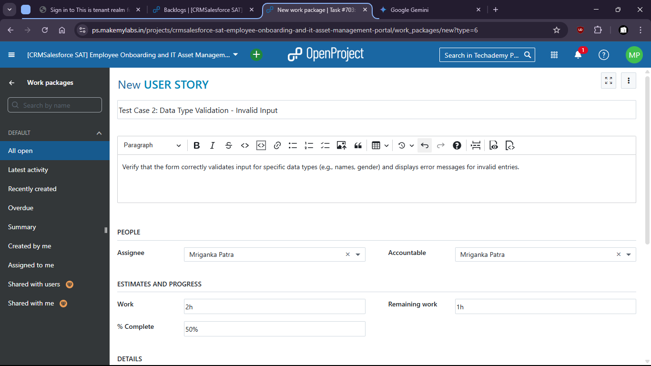

There is no option to put invalid data and submit wrong format.

